Apply filters to SQL queries

Project description

As a security professional, I investigated potential system vulnerabilities by analyzing organizational data within the employees and log_in_attempts tables. Using SQL, I applied precise filters to isolate suspicious after-hours activity, track login attempts across specific dates, and exclude known safe locations. This process allowed me to transform thousands of raw data points into targeted lists for security updates and incident response, ensuring the organization's digital assets remained protected.

Retrieve after hours failed login attempts
I investigated a potential security incident by filtering the log_in_attempts table to identify high-risk activity. Specifically, I targeted failed logins that occurred after standard business hours (18:00), which is a common indicator of unauthorized access or brute-force attempts.
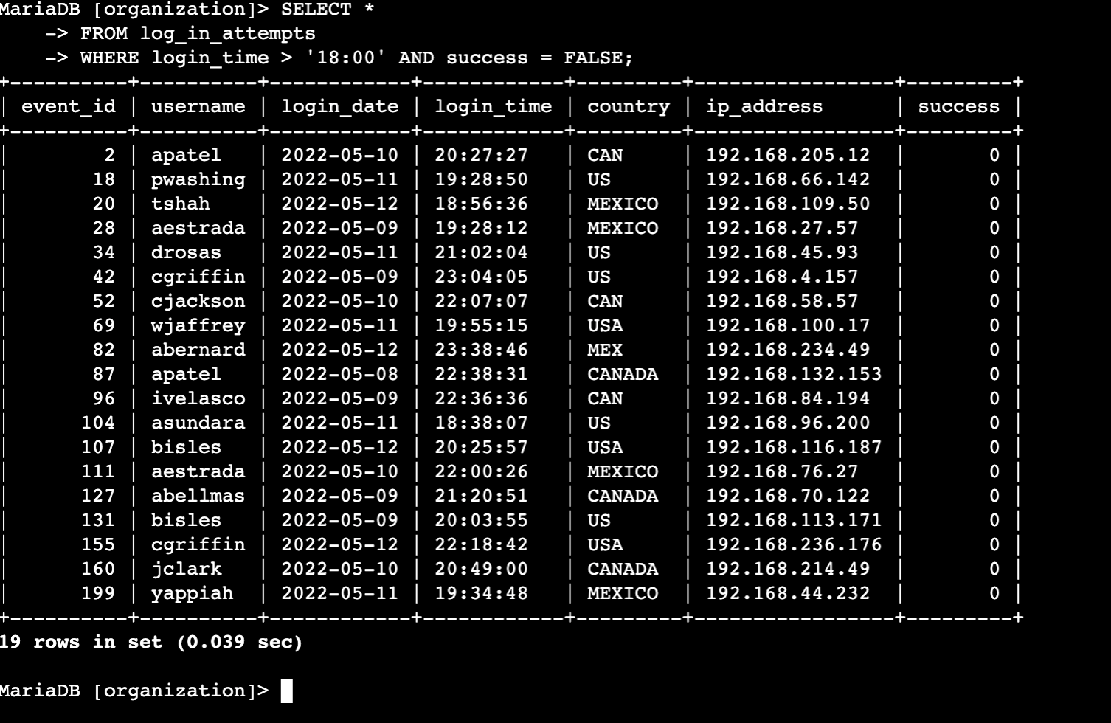

This query allows me to provide a clean, targeted list of potential security breaches. It removes "normal" daytime traffic and successful logins, letting me focus entirely on the anomalies that require immediate security review.

Retrieve login attempts on specific dates
To investigate a suspicious event that occurred on 2022-05-09, I expanded my search to include the day prior. This allowed me to look for any lead-up activity or patterns that might have started 24 hours earlier.

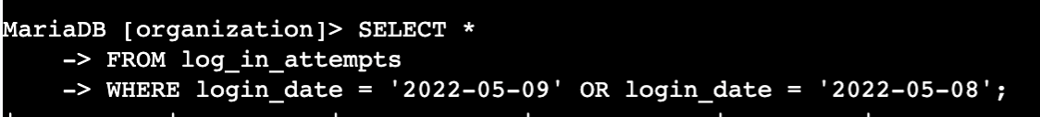

This query successfully captures a 48-hour window of login activity. By broadening the filter, I can see if the suspicious behavior was an isolated incident or part of a multi-day attempt to compromise the system.

Retrieve login attempts outside of Mexico
After confirming that the recent suspicious activity did not originate from Mexico, I filtered the log_in_attempts table to exclude all records from that region. This allowed me to focus my investigation on other geographical sources that could be responsible for the incident.
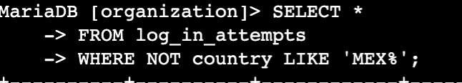

By using NOT combined with LIKE, I ensured that no variations of the excluded country would slip through. This narrowed the scope of the investigation to only the relevant "outside" traffic, making it much easier to spot anomalies from other locations.

Retrieve employees in Marketing
I was tasked with identifying specific machines in the Marketing department located within the East building for scheduled security updates. Since the office numbers vary (e.g., East-170, East-320), I used a pattern-matching filter to capture every relevant room in that wing of the building.
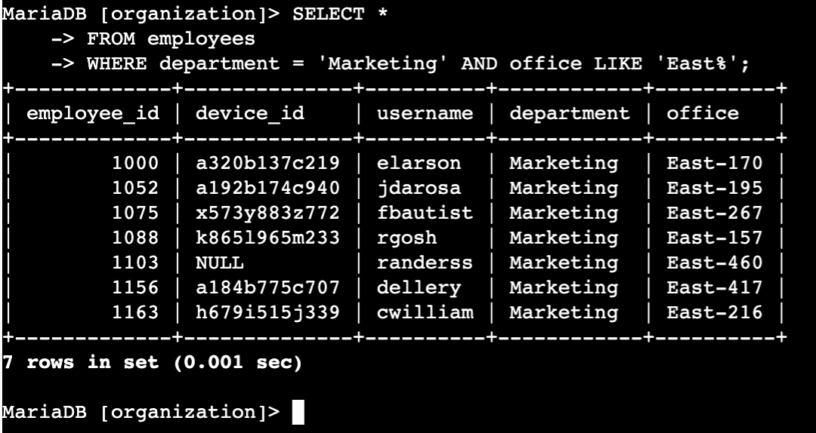

This query provides the hardware team with a precise list of machines. By combining an exact match for the department with a wildcard match for the building location, I ensured no Marketing employees in the East wing were overlooked for these critical updates.

Retrieve employees in Finance or Sales
I was tasked with identifying all employees in the Sales and Finance departments to facilitate a specialized security update. Since the update applies to both groups, I needed a query that would pull records for anyone belonging to either department.

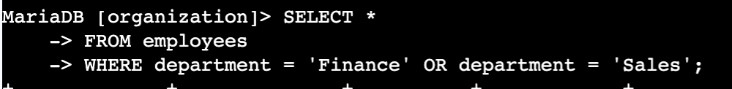
This query efficiently gathers the necessary data for a multi-department update. Using the OR logic is the most direct way to bridge two distinct groups into a single, actionable list for the security team.

Retrieve all employees not in IT
I was tasked with identifying all employees who still need a specific security update. Since the Information Technology department had already received this patch, I filtered the employees table to exclude them, ensuring the update is only rolled out to the remaining departments.

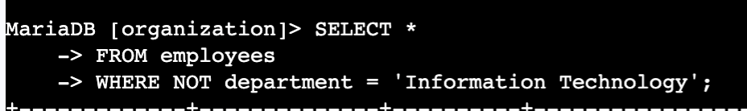

This query provides a clean, automated way to generate a distribution list for the remaining updates. It prevents redundant work by filtering out the IT staff who are already compliant, allowing the security team to focus their resources on the departments that still require attention.

Summary
In this project, I acted as a security professional to investigate potential system vulnerabilities by filtering large datasets within the employees and log_in_attempts tables. I used specialized SQL queries with AND, OR, and NOT operators to isolate suspicious after-hours logins, identify international access patterns, and generate targeted lists for department-wide security updates. By converting raw logs into actionable intelligence, I was able to efficiently prioritize risks and ensure that critical security patches reached the correct employee machines.

